DATASCIENCEWITHPYTHON

CapstoneProjectReport
BreastCancerDiagnosisfromCell-NucleusMeasurements:AnEnd-to-End Data Science Pipeline

Preparedby:[D.DHARANI]
InternshipProgramme:DataSciencewithPython
Tools:Python,pandas,NumPy,scikit-learn,matplotlib,seaborn

Contents

- IntroductionandProblemStatement
Breast cancer is one of the most common cancers worldwide, and early, accurate diagnosis strongly improves patient outcomes. A fine needle aspirate (FNA) is a minimally invasive test in which a small sampleofcellsistakenfromabreastmassandexaminedunderamicroscope.Fromadigitisedimage ofthesample,thesizeandshapeofeachcellnucleuscanbemeasured.Thequestionaddressedinthis projectiswhetherthesenumericalmeasurementsalonecanseparatemalignantfrombenignmasses reliably.
Problem statement. Given 30 numeric measurements describing the cell nuclei in a digitised FNA image,(a)predictwhetheratumourismalignantorbenign(supervisedclassification),and(b)discover whetherthemeasurementscontainnaturalstructurethatseparatesthetwogroupswithoutusingthe diagnosis labels (unsupervised learning).
Whythisproblemsuitsdatascience.Thedataarenumeric,cleanandlabelledbyexpertdiagnosis,so theeffectofeachpipelinedecision(scaling,featureselection,modelchoice,tuning)canbemeasured. Thecostoferrorsisalsounequal:missingamalignanttumour(falsenegative)isfarmoreseriousthan afalsealarm.Thismakesthechoiceofevaluationmetricarealdesigndecisioninsteadofaformality.

Objectives
- Acquireapublicdatasetanddocumentitsorigin.
- Cleanandvalidatethedata,anddecidehowtotreatoutliersandcorrelatedfeatures.
- Performexploratorydataanalysis(EDA)toidentifythemostinformativefeatures.
- Applyunsupervisedmethods(PCAandK-Means)andsupervisedmethods(fiveclassifiers with cross-validation and hyperparameter tuning).
- Evaluatewithmetricssuitedtothemedicalcontext(recall,precision,F1,ROC-AUC)and analyse the errors.
- Giverecommendationsandreflectonchallenges,limitationsandfurtherwork.
Successcriterion.Aclassifierwithcross-validatedandtestF1above0.95forthemalignantclass,with recall reported separately, and a clear explanation of which features drive the result.

MethodologicalApproach
Theprojectfollowsastandard,reproduciblepipeline.Everystepusesafixedrandomseed(42),andall preprocessing that learns from data (scaling) is placed inside a scikit-learn Pipeline so that it is fitted only on training folds. This prevents data leakage.
Table1:Pipelineoverview

Phase | Whatwasdone | Maintools
1.Datacollection | LoadtheUCIBreastCancerWisconsin(Diagnostic)data; encode malignant as the positive class | scikit-learndatasets, pandas
2.Datacleaning | Checkmissingvalues,duplicates,constants,outliers, skewness and multicollinearity | pandas,NumPy
3.EDA | Classbalance,distributions,boxplots,correlationanalysis | matplotlib,seaborn
4.Unsupervised learning | Standardise,thenPCAforstructureandK-Meansfor clustering | PCA,KMeans,silhouette, ARI

Phase | Whatwasdone | Maintools
5.Supervised learning | 80/20stratifiedsplit,5-foldCVoffivemodels,gridsearch tuning | Pipeline,GridSearchCV
6. Evaluation | Held-outtestsetmetrics,confusionmatrix,ROC,threshold analysis, error and importance analysis | sklearn.metrics, permutationimportance
7. Insights | Recommendations,limitations,reflection | n/a

DataCollection
The data come from the Breast Cancer Wisconsin (Diagnostic) dataset, created by Wolberg, Street andMangasarianattheUniversityofWisconsinandhostedbytheUCIMachineLearningRepository.It isapublicbenchmarkdistributedwithscikit-learn,whichmakestheprojectfullyreproduciblewithout any manual download. The dataset contains 569 patients and 30 numeric features.
For each nucleus, ten base measurements were computed: radius, texture, perimeter, area, smoothness, compactness, concavity, concave points, symmetry and fractal dimension. Each is summarised per image as the mean, the standard error and the worst (mean of the three largest values), giving 10 × 3 = 30 features.
fromsklearn.datasetsimportload_breast_cancer import pandas as pd

raw=load_breast_cancer(as_frame=True) df = raw.frame.copy()

#In scikit-learn, target 0 = malignant and 1 = benign.
#Weflipitsothattheclassofinterest(malignant)isthepositiveclass1. df["y"] = 1 - df["target"]
df["diagnosis"]=df["y"].map({1:"Malignant",0:"Benign"}) df = df.drop(columns="target")
df.to_csv("breast_cancer_raw.csv",index=False)

Flipping the label matters: precision and recall are computed for the positive class, so the malignant classmustbeclass1forrecalltoanswerthequestionthatmattersclinically,namely"whatfractionof cancersdidwecatch?".Thedatacontain212malignant(37.3%)and357benign(62.7%)cases,amild class imbalance.

DataCleaningandPreprocessing
Dataqualitycheckswererunbeforeanyanalysis.Theresultsaresummarisedbelow.
Table2:Dataqualitychecks

Check | Result | Decision
Missingvalues | 0 | Noimputationneeded
Duplicaterows | 0 | Nonetoremove
Constantcolumns | 0 | Nonetoremove
Outliers(IQRrule,1.5× IQR) | 608cellsin171rows(30.1%) | Kept(seebelow)

Check | Result | Decision
Mostskewedfeature | areaerror(skew5.45) | Handledbyscalingandrobust models
Featurepairswith|r|> 0.95 | 7featuresflagged | Testedareducedsetof23 features
Featurescale | Areaisinhundreds,smoothnessbelow 0.2 | StandardisationinsidePipeline

Outliers. Nearly a third of the rows contain at least one value outside the IQR fence, most of them in the"error"features(areaerroralonehas65).Thesearenotdata-entrymistakes.Theycorrespondto genuinely large or irregular tumours, which are exactly the cases the model should learn from. Removing them would discard many malignant cases and bias the model towards typical benign samples,sotheywerekept.Standardisation,andmodelssuchasSVMwithanRBFkernelandrandom forests, tolerate them reasonably well.
Multicollinearity.Sizefeatures(radius,perimeter,area)arealmostperfectlycorrelatedbecausethey describe the same geometric quantity. Seven features with pairwise correlation above 0.95 were identified (mean perimeter, mean area, perimeter error, area error, worst radius, worst perimeter, worst area). Rather than dropping them blindly, two feature sets were compared in cross-validation: all 30 features and the reduced 23 features (Section 6.3).
print("Missingvalues:",df[feats].isna().sum().sum()) print("Duplicate rows :", df.duplicated().sum())

# IQR outlier count
q1,q3=df[feats].quantile(.25),df[feats].quantile(.75) iqr = q3 - q1
out=(df[feats]<q1-1.5*iqr)|(df[feats]>q3+1.5*iqr) print("Rows with an outlier:", out.any(axis=1).sum())

#Highlycorrelatedfeatures(uppertriangleofthecorrelationmatrix) corr = df[feats].corr().abs()
upper=corr.where(np.triu(np.ones(corr.shape),1).astype(bool)) drop = [c for c in upper.columns if (upper[c] > 0.95).any()]
reduced = [f for f in feats if f not in drop]

ExploratoryDataAnalysis

Classbalance
Benigncasesoutnumbermalignantonesbyabout1.7to1.Theimbalanceismild,sostratifiedsplitting is used everywhere so that each split keeps the same class ratio, and F1 and recall are reported in addition to accuracy.

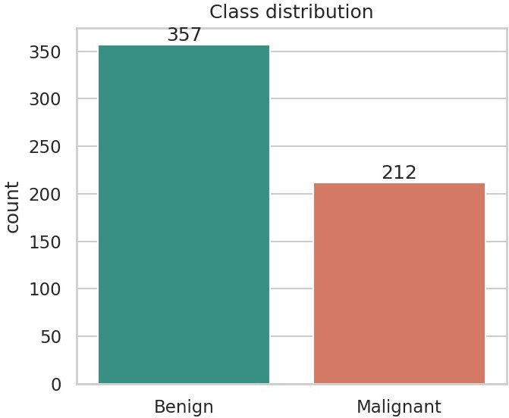
Figure1:Classdistributionofthetarget

Featuredistributionsbydiagnosis
Malignant tumours have clearly larger nuclei and more irregular shapes. The group averages below showthesizeofthegap:meanradiusis12.15forbenignand17.46formalignant,andmeanconcave points is roughly 3.4 times higher in malignant cases. Mean smoothness differs much less (0.092 vs 0.103), so it is a weaker separator on its own.
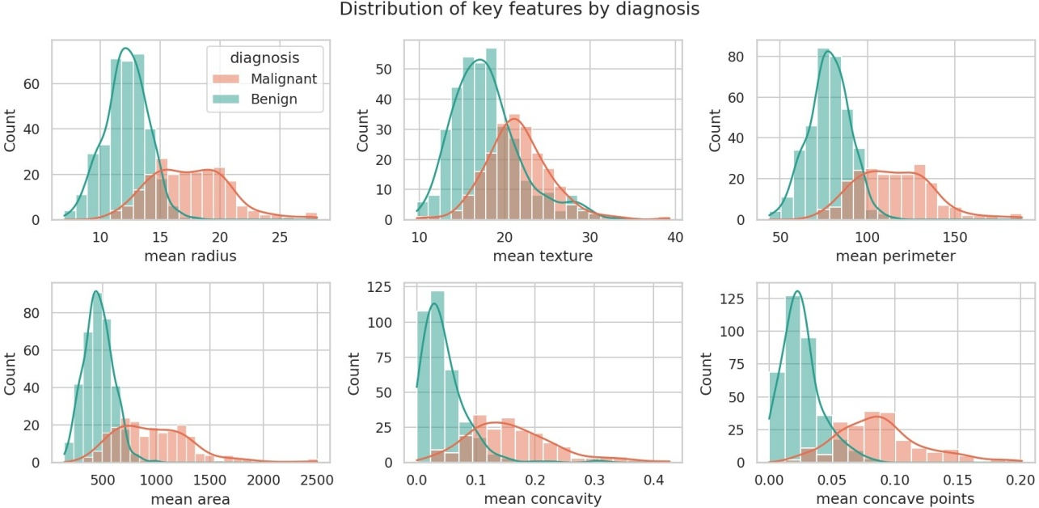
Figure2:Histogramswithdensitycurvesforsixkeyfeatures,splitbydiagnosis

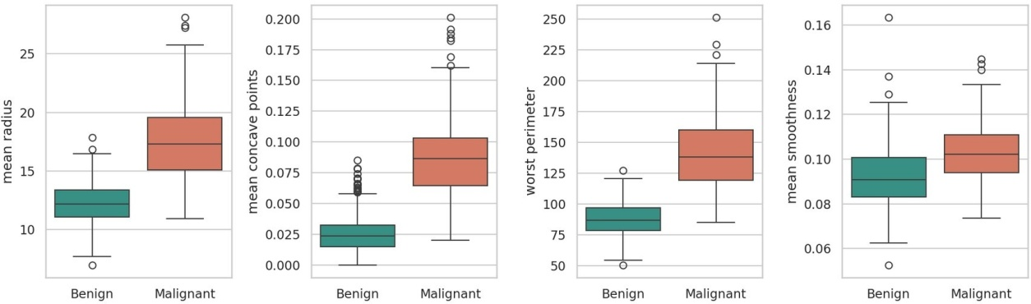
Figure3:Boxplotsoffourfeaturesbydiagnosis

The histograms of size-related features (radius, perimeter, area) and of concavity show two overlappingbutvisiblyshifteddistributions.Theoverlapexplainswhynosinglefeatureisenoughand a multivariate model is needed.

Correlationanalysis
The features most correlated with malignancy are worst concave points (r = 0.794), worst perimeter (0.783),meanconcavepoints(0.777),worstradius(0.776)andmeanperimeter(0.743).Featuressuch astextureerror,meanfractaldimensionandsmoothnesserrorhavealmostnolinearrelationshipwith the diagnosis (|r| < 0.07). The heat map also shows large blocks of near-perfect correlation among radius, perimeter and area.
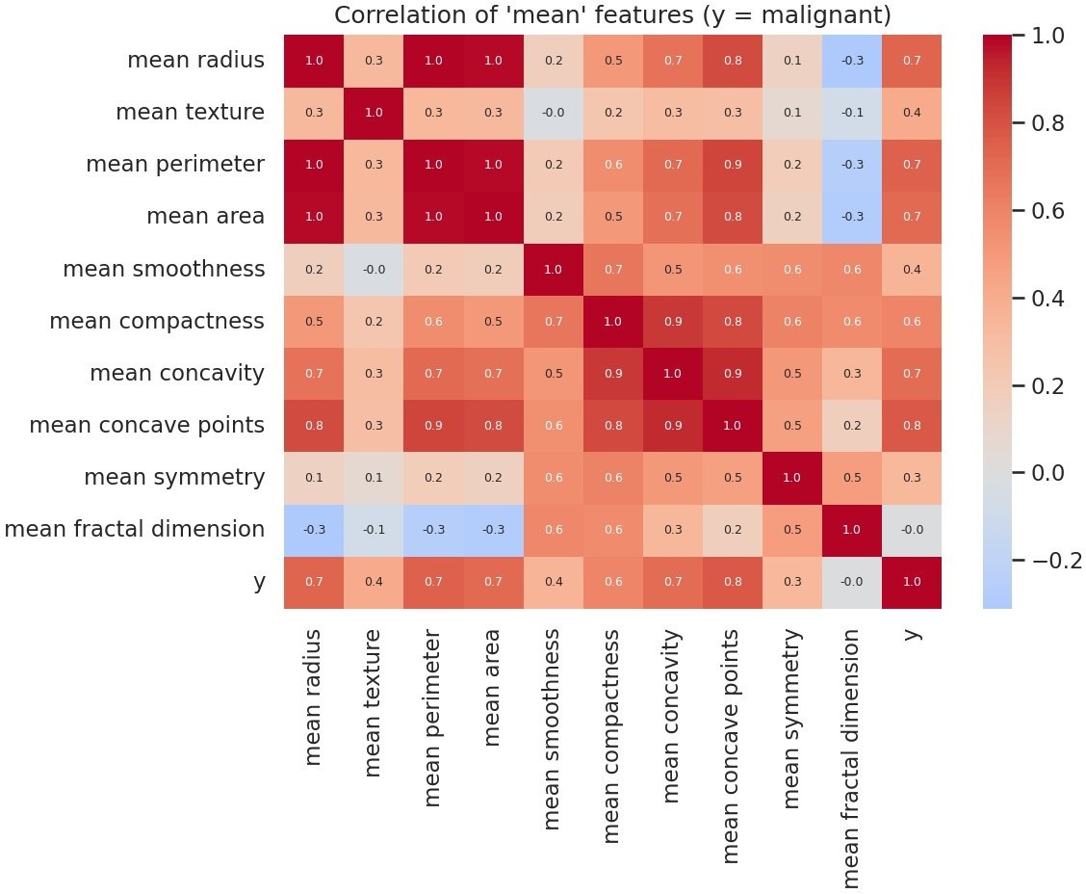
Figure4:Correlationheatmapofthe"mean"featuresandthetargety(1=malignant)

KeyEDAfindings
    - Shapeirregularity(concavepoints,concavity)andsize(radius,perimeter,area)arethe strongest signals of malignancy.

    - Thedatasetisclean,buthasskewedfeaturesandmanygenuineoutliers,soscalingis essential for distance- and margin-based models.
    - Strongmulticollinearitymeansindividualfeatureimportancesmustbeinterpretedwith care.

Modeling

Unsupervisedlearning:PCA
Principal Component Analysis was applied to the standardised data to see how much structure is present and whether the two diagnoses separate without labels being used. The first component explains44.3%ofthevarianceandthesecond19.0%,sotwocomponentsalreadycapture63.2%. 10 components are enough for 95% of the variance, which confirms that the 30 features are highly redundant. In the two-dimensional projection the benign and malignant groups form two largely separate clouds with a small overlap region.
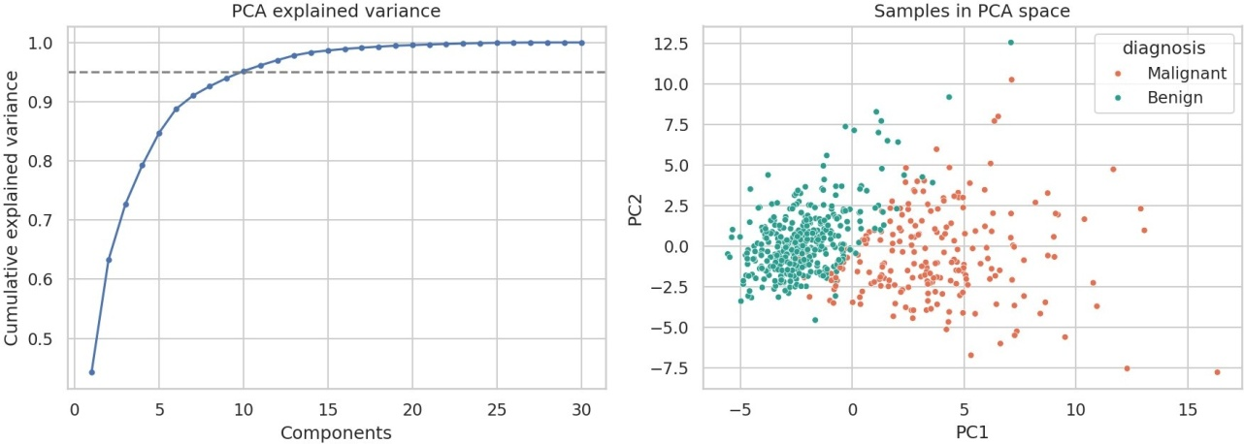
Xs=StandardScaler().fit_transform(df[feats]) pca = PCA(random_state=42).fit(Xs)
cum = np.cumsum(pca.explained_variance_ratio_)
n95 = np.argmax(cum >= 0.95) + 1 #componentsfor95%variance Z = PCA(2, random_state=42).fit_transform(Xs)

Figure5:Cumulativeexplainedvariance(lek)andsamplesprojectedonthefirsttwoprincipalcomponents(right)

Unsupervisedlearning:K-Meansclustering
K-Means was run for k = 2 to 8 on the standardised data, without using the diagnosis. The silhouette scoreishighestatk=2(0.343)andfallsforlargerk(0.314atk=3,0.283atk=4),sothedatanaturally support two groups. The elbow curve does not show a sharp bend, which is typical for real data with overlapping groups.
Tojudgetheclusters,theywerecomparedwiththetruediagnosesonlyafterclustering.TheAdjusted Rand Index is 0.654 and the clusters agree with the diagnosis for 90.5% of patients. Of 357 benign cases,339fellinthebenign-likeclusterand18inthemalignant-likeone;of212malignantcases,176 fell in the malignant-like cluster and 36 in the benign-like one. A silhouette of 0.343 indicates moderate, not sharp, separation.
for k in range(2, 9):
km= KMeans(k, n_init=10, random_state=42).fit(Xs)

sil.append(silhouette_score(Xs,km.labels_))

km=KMeans(2,n_init=10,random_state=42).fit(Xs) print(adjusted_rand_score(y, km.labels_))
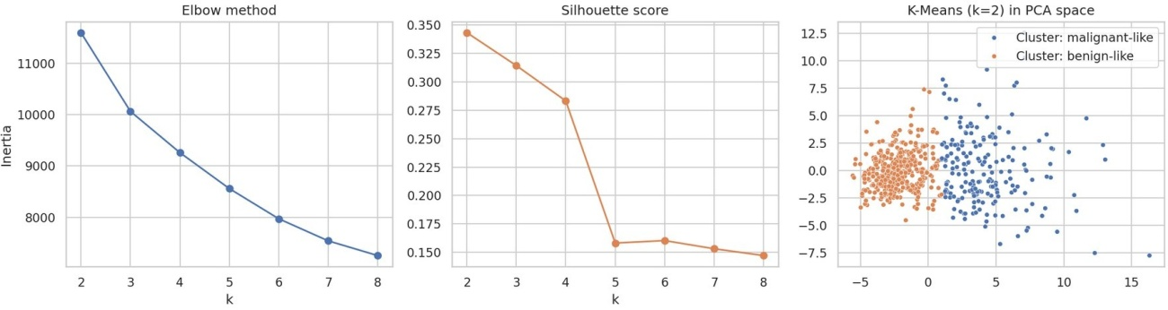
Figure6:Elbowcurve,silhouettescoresandK-Means(k=2)clustersshowninPCAspace

Interpretation. Roughly 90% of patients can be grouped correctly with no labels at all, which shows that the diagnosis is strongly encoded in the measurements. The remaining 10% sit in the overlap region and need a supervised model that can learn a more precise boundary.

Supervisedlearning:modelcomparison
Thedataweresplit80/20withstratificationinto 455training and 114test patients.Thetestsetwas not touched until the final evaluation. Five models covering different families were compared with stratified 5-fold cross-validation on the training data only. Each model sits in a Pipeline with a StandardScaler.
Xtr,Xte, ytr, yte =train_test_split(X, y, test_size=0.2, stratify=y, random_state=42)

def pipe(model):
returnPipeline([("sc", StandardScaler()),("m", model)])

models={"LogisticRegression":pipe(LogisticRegression(max_iter=2000)), "KNN (k=5)": pipe(KNeighborsClassifier(5)),
"SVM (RBF)": pipe(SVC(probability=True)),
"Random Forest": pipe(RandomForestClassifier(300,random_state=42)), "Gradient Boosting": pipe(GradientBoostingClassifier(random_state=42))}

cv= StratifiedKFold(5, shuffle=True, random_state=42)
scoring={"acc":"accuracy","prec":"precision","rec":"recall","f1":"f1","auc":"roc_auc"} for name, m in models.items():
res= cross_validate(m, Xtr, ytr, cv=cv, scoring=scoring)

Table3:5-foldcross-validationresultsonthetrainingdata(malignant=positiveclass)

Model | Accuracy | Precision | Recall | F1 | ROC-AUC | F1std | F1(23 feats)
LogisticRegression | 0.974 | 0.977 | 0.953 | 0.964 | 0.996 | 0.021 | 0.957
KNN(k=5) | 0.965 | 0.988 | 0.918 | 0.951 | 0.987 | 0.026 | 0.945
SVM(RBF) | 0.971 | 0.977 | 0.947 | 0.961 | 0.995 | 0.008 | 0.955
RandomForest | 0.960 | 0.958 | 0.935 | 0.946 | 0.988 | 0.023 | 0.945
GradientBoosting | 0.967 | 0.965 | 0.947 | 0.955 | 0.991 | 0.020 | 0.952

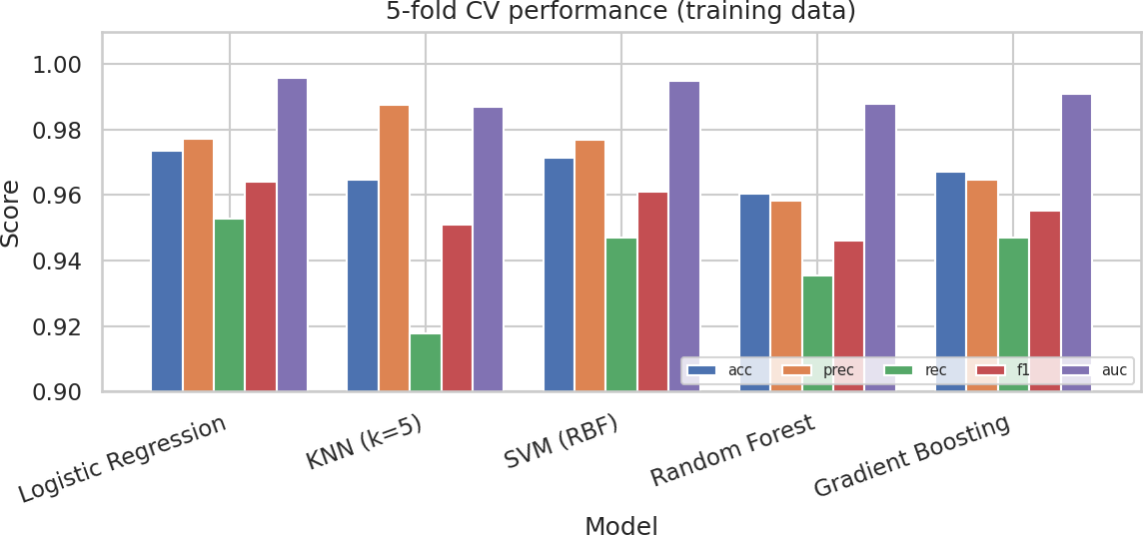

Figure7:Cross-validationscoresforthefivemodels

Findings. All models perform strongly (accuracy 0.96 to 0.97, ROC-AUC 0.988 to 0.996). Logistic Regression (F1 0.964) and the RBF SVM (F1 0.961) lead, and the SVM has the smallest fold-to-fold variation(std0.008),soitisthemoststable.KNNhasthehighestprecision(0.988)butthelowestrecall (0.918), so it misses the most cancers. Random Forest was the weakest in F1 (0.946). That a simple linearmodelmatchescomplexensemblessuggeststhattheclassesarealmostlinearlyseparableinthe standardised feature space.
Featureset.Foreverymodelthereduced23-featuresetgaveaslightlylowerorequalcross-validated F1thanthefull30features(forexampleLogisticRegression0.957vs0.964).Thedifferencesaresmall, butthereisnoevidencethatremovingthecorrelatedfeatureshelps,sothefullfeaturesetwaskept.

Hyperparametertuning
The two most promising models were tuned with a grid search optimising F1 under the same cross-validation.FortheSVM,thegridcoveredC ∈{0.1,1,10,100},gamma ∈{scale,0.001,0.01,0.1}and kernel∈{rbf,linear}.ThebestsettingwasC=10,gamma=scale,kernel=rbf,withacross-validated F1 of 0.9674 (up from 0.9610 with defaults). For Logistic Regression the best regularisation strength was C = 1, with a cross-validated F1 of 0.9640, essentially the same as the default.
grid = GridSearchCV(
pipe(SVC(probability=True,random_state=42)),
{"mC":[0.1, 1, 10, 100],
"mgamma": ["scale", 0.001, 0.01, 0.1],
"mkernel": ["rbf", "linear"]},
cv=cv,scoring="f1",n_jobs=-1).fit(Xtr,ytr) print(grid.best_params_, grid.best_score_)

Evaluation

Choiceofmetrics
Accuracy alone can hide serious problems when errors have unequal cost. The evaluation therefore reports:

    - Recall(sensitivity)formalignantcases:ofallrealcancers,howmanywerefound.Thisisthe most safety-critical metric.
    - Precision:ofallpatientsflaggedasmalignant,howmanyreallywere,whichrelatesto unnecessary biopsies and anxiety.
    - F1-score:theharmonicmeanofprecisionandrecall.
    - ROC-AUC:howwellthemodelranksmalignantabovebenigncasesregardlessofthe threshold.

Finalresultsontheheld-outtestset
Thetunedmodelswereevaluatedonceonthe114unseentestpatients(72benign,42malignant).
Table4:Test-setperformance(FN=missedcancers,FP=falsealarms)

Model | Accuracy | Precision | Recall | F1 | ROC-AUC | FN | FP
Tuned SVM | 0.974 | 1.000 | 0.929 | 0.963 | 0.993 | 3 | 0
TunedLogisticRegression | 0.965 | 0.975 | 0.929 | 0.951 | 0.996 | 3 | 1
RandomForest | 0.974 | 1.000 | 0.929 | 0.963 | 0.994 | 3 | 0

Table5:Per-classreportforthetunedSVM

Class | Precision | Recall | F1 | Support
Benign | 0.960 | 1.000 | 0.980 | 72
Malignant | 1.000 | 0.929 | 0.963 | 42
Macroaverage | 0.980 | 0.964 | 0.971 | 114

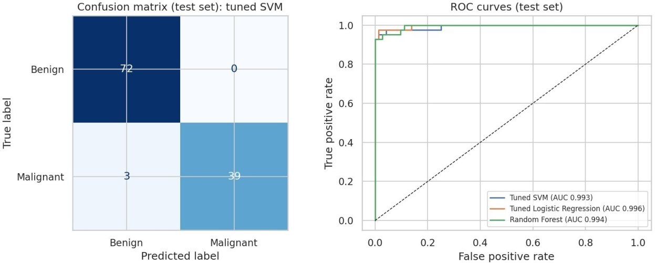
Figure8:ConfusionmatrixofthetunedSVM(lek)andROCcurvesofthreemodels(right),testset

Interpretation. The tuned SVM reached 97.4% accuracy, F1 0.963 and ROC-AUC 0.993 on unseen data, in line with the cross-validated F1 of 0.967. This agreement between cross-validation and test results indicates that the model generalises and that the tuning did not overfit. The success criterion (F1above0.95)wasmet.Precisionformalignantwas1.000(nofalsealarms)butrecallwas0.929:3of 42 cancers were missed.

The three models differ by at most one patient on the test set, so the differences between them are notstatisticallymeaningful.Withonly42malignanttestcases,onepatientchangesrecallbyabout2.4 percentage points. The model was chosen on the cross-validation evidence, and the test set is used only to confirm it.

Erroranalysis
All three errors are false negatives, where a malignant tumour was predicted benign. The model assigned them malignancy probabilities of 0.422, 0.025, 0.26. Two of them were borderline (probabilities0.26and0.42),meaningthemodelwasuncertain,whichascreeningworkflowcouldflag for review. One (0.025) was a confident miss, meaning that tumour looks typical of benign cases on these30measurements.Suchcasescannotbefixedbytuningandshowthelimitofwhatthefeatures contain.

Decisionthresholdanalysis
By default a case is called malignant when its predicted probability is at least 0.5. Because a missed cancer costs more than a false alarm, lowering the threshold trades precision for recall. The table below shows this trade-off for the tuned SVM.
Table6:Effectofthedecisionthresholdonthetestset(illustrative)

Threshold | Precision | Recall | Missedcancers(FN) | Falsealarms(FP)
0.5 | 1.000 | 0.929 | 3 | 0
0.4 | 0.976 | 0.952 | 2 | 1
0.3 | 0.952 | 0.952 | 2 | 2
0.2 | 0.891 | 0.976 | 1 | 5
0.1 | 0.820 | 0.976 | 1 | 9

Loweringthethresholdto0.2cutsmissedcancersfrom3to1atthepriceof5falsealarms.Caution: thistablewascomputedonthetestsettoillustratethetrade-off.Inarealdeploymentthethreshold must be chosen on validation data (or with cross-validated predictions), never on the test set, otherwise the reported performance is optimistic.

Featureimportance
Random Forest importance ranks worst perimeter (0.143), worst area (0.142) and worst concave points (0.113) highest, followed by mean concave points and worst radius. This agrees with the EDA. Permutation importance for the SVM, however, ranks worst texture (0.049), worst concavity (0.035) and mean concavity (0.030) first. The two methods disagree because the size features are almost perfectlycorrelated:whenoneofthemisshuffledthemodelcanstillrelyontheothers,soeachgetsa lowpermutationscore,whiletheforestsplitsimportanceamongthem.Textureandconcavityareless redundant,soshufflingthemhurtsmore.Thereliableconclusionisthatagroupofsizefeaturesanda group of shape (concavity) features both carry the signal, and single-feature rankings should not be over-interpreted.

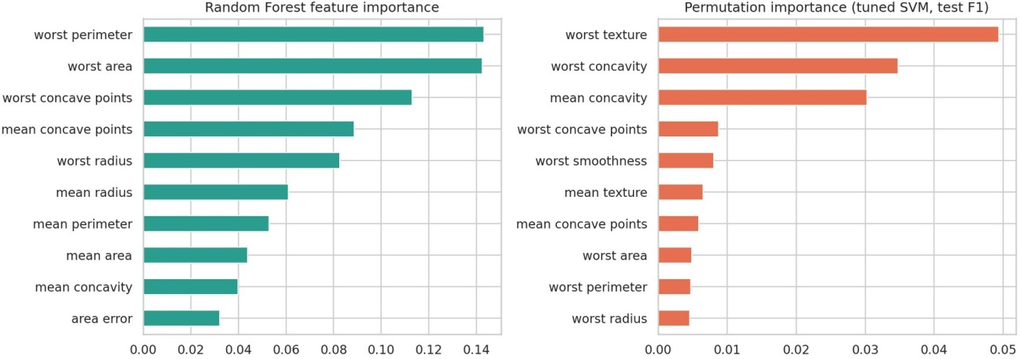
Figure9:RandomForestimportance(lek)andpermutationimportanceforthetunedSVM(right)

InsightsandRecommendations

Insights
    - Cell-nucleus measurements separate benign from malignant tumours very well: an unsupervisedK-Meansalreadygroupsabout90%correctly,andsupervisedmodelsreach about 97% accuracy with ROC-AUC above 0.99.
    - Size(radius,perimeter,area)andshapeirregularity(concavepoints,concavity)arethemain drivers of malignancy. Smoothness, fractal dimension and the error terms contribute little.
    - Asimple,interpretableLogisticRegressionperformsalmostaswellastunednon-linear models, so complexity is not needed for this problem.
    - Recallforcancer,notaccuracy,shouldbetheheadlinemetric,andalowerdecision threshold can raise it at a measurable cost in false alarms.

Recommendations
- Usethemodelasdecisionsupport,notasareplacementforapathologist. Caseswith intermediate probability should always be reviewed by an expert.
- Setthethresholdonvalidationdataaccordingtoclinicalcost. Athresholdnear0.3to0.4 would likely be a sensible starting point, to be confirmed on new data.
- PreferLogisticRegressionoratunedSVM inproduction:theyarefast,stableacrossfolds and easy to explain.
- Monitorperformanceafterdeploymentandre-validatewhentheimagingequipmentorthe patient population changes.
- Validateonanexternaldatasetfromadifferenthospitalbeforeanyrealuse.

ChallengesandSuccesses:AReflection

Challenges
    - Labeldirection.Thedatasetencodesmalignantas0.Leftunchanged,recallandprecision would have been reported for the benign class, which answers the wrong question. Recoding the target so that malignant is positive solved it.

    - Outliers. A third of the rows contain statistical outliers. Deleting them was tempting but wouldhaveremovedreallargetumours,sotheywerekeptandhandledthroughscalingand robust models.
    - Multicollinearity.Thesizefeaturesarenearlyidentical,whichmadefeatureimportance ambiguous.Comparingfullandreducedfeaturesetsandusingtwoimportancemethods gave a more honest picture.
    - Smalltestset.With114testpatients,onepredictionmovesrecallbymorethan2points,so I relied on cross-validation for model selection and did not over-read differences of one patient.
    - Avoidingdataleakage.ScalingandtuningwerekeptinsidePipelinesandcross-validation folds, and the test set was used once.

Successes
    - Acomplete,reproduciblepipelinefromacquisitiontorecommendations,usingboth unsupervised and supervised techniques.
    - Cross-validationandtestresultsagree,whichsupportstheclaimthatthemodelgeneralises.
    - Theevaluationwentbeyondaccuracy:recall,thresholdanalysis,calibrationoferrorsby probability, and two importance methods.

WhatI learned
Themostimportantlessonwasthatthemodelingstepisasmallpartofthework.Choicesaboutlabels, leakage, metrics and thresholds affected the conclusions more than the choice between algorithms did.Ialsolearnedtoreporthonestlimitations:a97%accuracyfiguremeanslittlewithoutknowingthe cost of the remaining errors.

LimitationsandFurtherWork
- Sizeandsource.569patientsfromoneinstitution;resultsmaynottransfertoother hospitals or scanners.
- Pre-computed features. The features were extracted from images beforehand. A convolutionalneuralnetworkworkingontherawimagescouldfindpatternsthese30 numbers miss.
- Noprobabilitycalibration.Calibration(Plattscalingorisotonicregression)wouldmakethe probabilities more trustworthy for threshold setting.
- Furthermodeling.Trynestedcross-validationfortuning,class-weightedtraining, XGBoost/LightGBM, and SHAP values for per-patient explanations.
- Statisticaltesting.Repeatedcross-validationwithpairedtestswouldshowwhetherthe small differences between models are real.
- Ethics.Anyclinicalusewouldneedregulatoryapproval,biaschecksacrosspatientgroups and expert oversight. This project is an educational exercise, not a medical device.

Conclusion
This project built a complete data science pipeline for breast cancer diagnosis on the Wisconsin Diagnostic dataset. After confirming the data were clean and deciding to keep genuine outliers, exploratory analysis showed that nucleus size and shape irregularity are the main signals. PCA and K-Meansshowedthatthediagnosisisvisibleinthedataevenwithoutlabels(90.5%agreement).Among fivesupervisedmodels,atunedRBFSVM(C=10)reached97.4%testaccuracy,F10.963andROC-AUC 0.993, with no false alarms but 3 missed cancers out of 42. Because a missed cancer is the costliest error, the main recommendation is to use the model as decision support with a lowered, validation-chosen threshold, and to validate on external data before any real use.

References
- Wolberg,W.H.,Street,W.N.,Mangasarian,O.L.(1995).BreastCancerWisconsin(Diagnostic)
DataSet.UCIMachineLearningRepository.https://archive.ics.uci.edu/dataset/17
- Street,W.N.,Wolberg,W.H.,Mangasarian,O.L.(1993).Nuclearfeatureextractionforbreast tumor diagnosis. IS&T/SPIE International Symposium on Electronic Imaging, 1905, 861-870.
- Pedregosa,F.etal.(2011).Scikit-learn:MachineLearninginPython.JournalofMachineLearning Research, 12, 2825-2830.
- McKinney,W.(2010).DataStructuresforStatisticalComputinginPython.Proceedingsofthe9th Python in Science Conference.
- Hunter,J.D.(2007).Matplotlib:A2DGraphicsEnvironment.ComputinginScienceand Engineering, 9(3), 90-95.
- Waskom,M.(2021).seaborn:statisticaldatavisualization.JournalofOpenSourceSoftware, 6(60), 3021.
- Rousseeuw,P.J.(1987).Silhouettes:agraphicalaidtotheinterpretationandvalidationofcluster analysis. Journal of Computational and Applied Mathematics, 20, 53-65.

